本期内容：
- 为什么使用Sort-Based shuffle
- Sort-Based shuffle实战
- Sort-Based shuffle内幕
- Sort-Based shuffle的不足
本次课程是从Spark 初级人才成功升级为Spark 中级人才的通道
- 为什么要使用Sort-Basedshuffle?
- Shuffle一般包含两阶段的任务：第一部分产生Shuffle数据的阶段（产生数据的阶段又叫Map阶段，额外补充：需要实现ShuffleManager中的getWriter来写数据，通过blockManager来写数据到Memory,Disk,Tachyon等，例如想非常快的使用shuffle，此时可以考虑把数据写在内存中，但是内存不稳定，可以考虑增加副本，建议采用MEMORY_AND_DISK_2）。
- 第二部分，使用shuffle数据的阶段(使用数据阶段又叫Reduce阶段，额外补充，需要实现ShuffleManager的getReader,Reader会向Driver去获取上一个Stage产生的Shuffle数据)
除了最后一个stage仅仅是reduce,而第一个stage仅仅是map之外，而中间所有的stage即是map也是reducer
override def registerShuffle[K, V, C](
shuffleId: Int,
numMaps: Int,
dependency: ShuffleDependency[K, V, C]): ShuffleHandle = {
if (SortShuffleWriter.shouldBypassMergeSort(SparkEnv.get.conf, dependency)) {
// If there are fewer than spark.shuffle.sort.bypassMergeThreshold partitions and we don't
// need map-side aggregation, then write numPartitions files directly and just concatenate
// them at the end. This avoids doing serialization and deserialization twice to merge
// together the spilled files, which would happen with the normal code path. The downside is
// having multiple files open at a time and thus more memory allocated to buffers.
new BypassMergeSortShuffleHandle[K, V](
shuffleId, numMaps, dependency.asInstanceOf[ShuffleDependency[K, V, V]])
} else if (SortShuffleManager.canUseSerializedShuffle(dependency)) {
// Otherwise, try to buffer map outputs in a serialized form, since this is more efficient:
new SerializedShuffleHandle[K, V](
shuffleId, numMaps, dependency.asInstanceOf[ShuffleDependency[K, V, V]])
} else {
// Otherwise, buffer map outputs in a deserialized form:
new BaseShuffleHandle(shuffleId, numMaps, dependency)
}
}
/**
* Get a reader for a range of reduce partitions (startPartition to endPartition-1, inclusive).
* Called on executors by reduce tasks.
*/
override def getReader[K, C](
handle: ShuffleHandle,
startPartition: Int,
endPartition: Int,
context: TaskContext): ShuffleReader[K, C] = {
new BlockStoreShuffleReader(
handle.asInstanceOf[BaseShuffleHandle[K, _, C]], startPartition, endPartition, context)
}
/** Get a writer for a given partition. Called on executors by map tasks. */
override def getWriter[K, V](
handle: ShuffleHandle,
mapId: Int,
context: TaskContext): ShuffleWriter[K, V] = {
numMapsForShuffle.putIfAbsent(
handle.shuffleId, handle.asInstanceOf[BaseShuffleHandle[_, _, _]].numMaps)
val env = SparkEnv.get
handle match {
case unsafeShuffleHandle: SerializedShuffleHandle[K @unchecked, V @unchecked] =>
new UnsafeShuffleWriter(
env.blockManager,
shuffleBlockResolver.asInstanceOf[IndexShuffleBlockResolver],
context.taskMemoryManager(),
unsafeShuffleHandle,
mapId,
context,
env.conf)

- Spark天生支持算子的链式表达式，所以Spark有很多Mpa和Reduce
- Spark的job会被划分很多Stage
如果只有一个Stage,则这个Job就相当于只有一个Mapper阶段，当然不会产生 shuffle，适合于简单的ETL
如果不止一个Stage，则最后一个Stage就是最终的Reducer，最左侧的第一个Stage就仅仅是整个job的Mapper,中间所有的任意一个Stage既是其父Stage的Reducer又是其子Stage的Mapper
二:Hash-based Shuffle
1.Spark Shuffle在最开始的时候只支持Hash-based Shuffle，默认Mapper阶段会为Reducer阶段的每一个Task单独创建一个文件来保存该Task中要使用的数据
优点:这种方式就是操作非常简单
缺点:但是在一些情况下（例如数据量非常大的情况下）会造成大量数据的随机磁盘I/O操作且会性能大量的消耗，(M*R，其中M代表Mapper中所有的并行任务数量，R代表Reducer中所有的并行任务数据)的Memory消耗（极易造成OOM)，这是致命的问题
- Hash-based Shuffle产生的问题
第一：不能够处理大规模的数据
第二：Spark不能运行在大规模的分布式集群上!
- Shuffle Consolidate机制
后来的改善是加入了Consolidate机制来将Shuffle时候产生的文件数量减少到C*R个(C代表在Mapper端同时能够使用的Cores的数量，R代表Reducer中所有的并行任务数量），但是此时如果Reducer端的并行数据分片过多的话则C*R可能已经过大，此时依旧没有逃脱文件打开过多的厄运
Consolidate并没有降低并行度，只是降低了临时文件的数量，此时Mapper端的内存消耗就会变少，所以OOM也就会降低，另外一方面磁盘的性能也会变得更好。

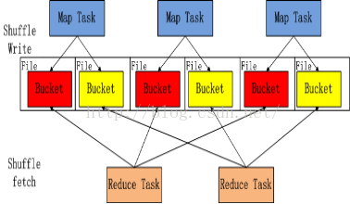

Spark在引入Sort-based Shuffle（Spark 1.1版本以前）比较适用于中小规模的大数据处理
三:Sort-Based Shuffle
- 为了让Spark在更大规模的集群上更高性能处理更大规模的数据，于是就引入了Sort-based shuffle!Hadoop Map reducer shuffle就是排序的（Spark 1.1版本开始，Spark可以胜任任意规模（包含PB级别及PB以上的级别）的大数据的处理，尤其是随着钨丝计划的引入和优化，把Spark更快速的在更大规模的集群处理更海量的数据的能力推向了一个新的巅峰
2.Spark支持至少三种类型的Shuffle
val shortShuffleMgrNames = Map(
"hash" -> "org.apache.spark.shuffle.hash.HashShuffleManager",
"sort" -> "org.apache.spark.shuffle.sort.SortShuffleManager",
"tungsten-sort" -> "org.apache.spark.shuffle.sort.SortShuffleManager")
val shuffleMgrName = conf.get("spark.shuffle.manager", "sort")
val shuffleMgrClass = shortShuffleMgrNames.getOrElse(shuffleMgrName.toLowerCase, shuffleMgrName)
实现ShuffleManager接口可以根据自己的业务实际需要最优化的使用自定义的Shuffle实现
3.Sort-based shuffle产生的文件数量正确的是2M(M代表Mapper阶段中并行的partition的总数量)个shuffle临时文件
4.Spark 1.6默认采用的就是Sort-based shuffle的方式
val shuffleMgrName = conf.get("spark.shuffle.manager", "sort")
上述的源码说明，你可以在Spark的配置文件中配置Spark框架运行时要使用的具体的ShuffleManager的实现。
修改conf/spark-default.conf加入如下内容：spark.shuffle.namager SORT
上述的源码说明，你可以在Spark的配置文件中配置Spark框架运行时要使用的具体的ShuffleManager的实现
为什么要使用shuffle,数据的分类计算，和数据的汇聚
- Sort-based Shuffle的工作方式如下：Shuffle的目的就是：数据分类，然后数据聚集
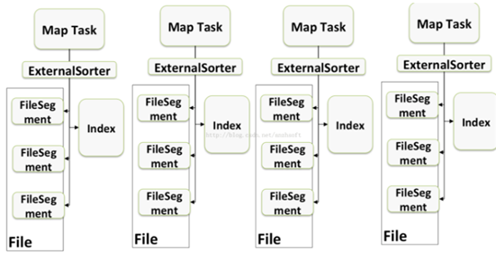

- 首先每个ShuffleMap Task不会为每个Reducer中的Task生成一个单独的文件，相反，Sort-based shuffle会把Mapper中每个ShuffleMapTask所有的输出数据Data只写到一个文件中，因为每个shuffleMapTask中的数据会被分类，所以Sort-based shuffle使用了index文件存储了具体shuffleMapTask输出数据在同一个Data文件中是如何分类的信息!!
- 基于Sort-base的shuffle会在Mapper中的每一个shuffleMapTask中产生两个文件:data文件和index文件，其中Data文件是存储当前Task的shuffle输出的，而index文件中则存储了Data文件中的数据通过Partitioner的分类信息，此时下一个阶段的Stage中的Task就是根据这个Index文件获取自己所要抓取的上一个Stage中的ShuffleMapTask产生的数据的，Reducer就是根据index文件来获取属于自己的数据
Sort-based shuffle产生的文件数量正确的是2M(M代表Mapper阶段中并行的partition的总数量)个shuffle临时文件
回顾整个Shuffle的历史，shuffle产生的临时文件的数量的变化一次为：
Basic Hash Shuffle
Consalidate方式的Hash Shuffle:C*R
Sort-based shuffle:2M
R在默认情况下和M相等
问题：在Sort-based shuffle中Reducer是如何获取自己需要的数据的了，具体而言，Reducer首先找Driver去 获取父Stage中每个ShuffMapTask输出的位置信息，根据位置信息获取index文件，解析index文件，从解析的index文件中获取Data文件中属于自己的那部分内容:
Sorted-based Shuffle与排序没有关系，Sorted-based Shuffle并没有对内容进行排序，Sorted-based Shuffle是对SHuffle进行Sort,对我们具体要执行的内容没有排序。
Reducer在什么时候去fetch数据?
当parent Stag的所有ShuffleMapTask结束后再fetch,等所有的ShuffleMapTask执行完之后，边fetch边计算。
通过动手实践确实证明了Sort-based Shuffle产生了2M个文件，M是并行Task的数量

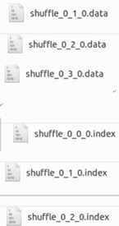
shuffle_0_3_0.index

二:默认Sort-based shuffle的几个缺陷
- 如果Mapper中Task的数量过大，依旧会产生很多小文件，此时在shuffle传递数据的过程中到Reducer端，reduce会需要同时大量的记录来进行反序列化，导致大量的内存消耗和GC的巨大负担，造成系统缓慢甚至崩溃!
- 如果需要在分片内也进行排序的话，此时需要进行Mapper端和Reducer端的两次排序，这对性能也是一个巨大的消耗，如果在Mapper端按照key对结果进行排序，在Reducer中讲每个Mapper端排序的结果进行合并

shuffle和排序没有关系，SortBasedShuffle是对Shuffle进行Sort,对内容不进行排序
Sorted Shuffle Writer源码:
- ShuffleMapTask 的run Task方法
反序列化RDD和Dependency
调用SortShuffleManager的getWriter方法
writer方法写入结果.
override def runTask(context: TaskContext): MapStatus = {
// Deserialize the RDD using the broadcast variable.
val deserializeStartTime = System.currentTimeMillis()
val ser = SparkEnv.get.closureSerializer.newInstance()
//反序列化获得RDD和Dependency
val (rdd, dep) = ser.deserialize[(RDD[_], ShuffleDependency[_, _, _])](
ByteBuffer.wrap(taskBinary.value), Thread.currentThread.getContextClassLoader)
_executorDeserializeTime = System.currentTimeMillis() - deserializeStartTime
metrics = Some(context.taskMetrics)
var writer: ShuffleWriter[Any, Any] = null
//获得ShuffleManager
val manager = SparkEnv.get.shuffleManager
//获得SortShuffleManager的getWriter方法，获得PartitionID
writer = manager.getWriter[Any, Any](dep.shuffleHandle, partitionId, context)
//将结果写入到文件中
writer.write(rdd.iterator(partition, context).asInstanceOf[Iterator[_ <: Product2[Any, Any]]])
}
}
- SortShuffleManager复习了shuffleManager中的getWriter方法，源码如下:
/** Get a writer for a given partition. Called on executors by map tasks. */
override def getWriter[K, V](
handle: ShuffleHandle,
mapId: Int,
context: TaskContext): ShuffleWriter[K, V] = {
numMapsForShuffle.putIfAbsent(
handle.shuffleId, handle.asInstanceOf[BaseShuffleHandle[_, _, _]].numMaps)
val env = SparkEnv.get
handle match {
case unsafeShuffleHandle: SerializedShuffleHandle[K @unchecked, V @unchecked] =>
new UnsafeShuffleWriter(
env.blockManager,
shuffleBlockResolver.asInstanceOf[IndexShuffleBlockResolver],
context.taskMemoryManager(),
unsafeShuffleHandle,
mapId,
context,
env.conf)
case bypassMergeSortHandle: BypassMergeSortShuffleHandle[K @unchecked, V @unchecked] =>
new BypassMergeSortShuffleWriter(
env.blockManager,
shuffleBlockResolver.asInstanceOf[IndexShuffleBlockResolver],
bypassMergeSortHandle,
mapId,
context,
env.conf)
case other: BaseShuffleHandle[K @unchecked, V @unchecked, _] =>
new SortShuffleWriter(shuffleBlockResolver, other, mapId, context)
}
}
- SortShuffleWriter的write方法源码如下:
/** Write a bunch of records to this task's output */
override def write(records: Iterator[Product2[K, V]]): Unit = {
sorter = if (dep.mapSideCombine) {
require(dep.aggregator.isDefined, "Map-side combine without Aggregator specified!")
new ExternalSorter[K, V, C](
context, dep.aggregator, Some(dep.partitioner), dep.keyOrdering, dep.serializer)
} else {
// In this case we pass neither an aggregator nor an ordering to the sorter, because we don't
// care whether the keys get sorted in each partition; that will be done on the reduce side
// if the operation being run is sortByKey.
//创建ExternalSorter实例
new ExternalSorter[K, V, V](
context, aggregator = None, Some(dep.partitioner), ordering = None, dep.serializer)
}
//然后将结果通过insertAll写入缓存中
sorter.insertAll(records)
// Don't bother including the time to open the merged output file in the shuffle write time,
// because it just opens a single file, so is typically too fast to measure accurately
// (see SPARK-3570).
//获取当前文件的输出路径
val output = shuffleBlockResolver.getDataFile(dep.shuffleId, mapId)
val tmp = Utils.tempFileWith(output)
//创建BlockId
val blockId = ShuffleBlockId(dep.shuffleId, mapId, IndexShuffleBlockResolver.NOOP_REDUCE_ID)
//调用ExternalSorter.writePartitionedFile将中间结果进行持久化
val partitionLengths = sorter.writePartitionedFile(blockId, tmp)
//创建文件的索引
shuffleBlockResolver.writeIndexFileAndCommit(dep.shuffleId, mapId, partitionLengths, tmp)
mapStatus = MapStatus(blockManager.shuffleServerId, partitionLengths)
}
其中ShuffleBlockID记录ShuffleID和MpID获得Block
// Format of the shuffle block ids (including data and index) should be kept in sync with
// org.apache.spark.network.shuffle.ExternalShuffleBlockResolver#getBlockData().
@DeveloperApi
case class ShuffleBlockId(shuffleId: Int, mapId: Int, reduceId: Int) extends BlockId {
override def name: String = "shuffle_" + shuffleId + "_" + mapId + "_" + reduceId
}
- 其中writeIndexFileAndCommit方法
/**
* Write an index file with the offsets of each block, plus a final offset at the end for the
* end of the output file. This will be used by getBlockData to figure out where each block
* begins and ends.
*
* It will commit the data and index file as an atomic operation, use the existing ones, or
* replace them with new ones.
*
* Note: the `lengths` will be updated to match the existing index file if use the existing ones.
* */
def writeIndexFileAndCommit(
shuffleId: Int,
mapId: Int,
lengths: Array[Long],
dataTmp: File): Unit = {
val indexFile = getIndexFile(shuffleId, mapId)
val indexTmp = Utils.tempFileWith(indexFile)
val out = new DataOutputStream(new BufferedOutputStream(new FileOutputStream(indexTmp)))
Utils.tryWithSafeFinally {
// We take in lengths of each block, need to convert it to offsets.
var offset = 0L
out.writeLong(offset)
for (length <- lengths) {
offset += length
out.writeLong(offset)
}
} {
out.close()
}
val dataFile = getDataFile(shuffleId, mapId)
// There is only one IndexShuffleBlockResolver per executor, this synchronization make sure
// the following check and rename are atomic.
synchronized {
val existingLengths = checkIndexAndDataFile(indexFile, dataFile, lengths.length)
if (existingLengths != null) {
// Another attempt for the same task has already written our map outputs successfully,
// so just use the existing partition lengths and delete our temporary map outputs.
System.arraycopy(existingLengths, 0, lengths, 0, lengths.length)
if (dataTmp != null && dataTmp.exists()) {
dataTmp.delete()
}
indexTmp.delete()
} else {
// This is the first successful attempt in writing the map outputs for this task,
// so override any existing index and data files with the ones we wrote.
if (indexFile.exists()) {
indexFile.delete()
}
if (dataFile.exists()) {
dataFile.delete()
}
if (!indexTmp.renameTo(indexFile)) {
throw new IOException("fail to rename file " + indexTmp + " to " + indexFile)
}
if (dataTmp != null && dataTmp.exists() && !dataTmp.renameTo(dataFile)) {
throw new IOException("fail to rename file " + dataTmp + " to " + dataFile)
}
}
}
}
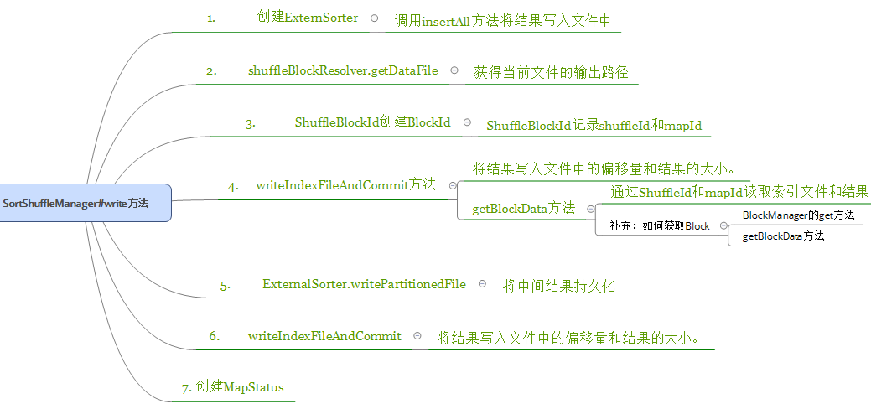
三:默认Sort-based Shuffle的几个缺陷:
- 如果Mapper中Task的数量过大，依旧会产生很多小文件，此时在Shuffle传递数据的过程中到Reducer端，reduce会需要同时打开大量的记录来进行反序列化，导致大量的内存消耗和GC的巨大负担，造成系统缓慢深圳崩溃!
- 如果需要在分片内也进行排序的话，此时需要进行Mapper端和Reducer端的两次排序
优化:
可以改造Mapper和Reducer端，改框架来实现一次排序。
频繁GC的解决办法是：钨丝计划
全文总结如下:
